

[**Burhan Email**](mailto:burhanrgrg8@gmail.com)

**Burhan Ul Haq**

**24**

**08**

**Abdullah Ahmed**

[**YouTube Link**](https://youtu.be/028KkUwSJ1c)

[**GitHub Repository**](https://github.com/Burhan-Ul-Haq/BanoQabil-3.0-Python-Course/tree/main/Final-Term%20Project)

[**GitHub Repository**](https://github.com/abdullah-459/Final-Term-Project-Bano-Qabil3.0-By-Abdullah-Ahmed-And-Burhan-ul-Haque)

[**Abdullah Email**](mailto:abdullah.official@gmail.com)

**Q: What does it do?**

**Ans.** **Fitness Flow** is a Workout Tracker made for Fitness Geeks who want to Prioritize their Fitness, it can help people keep track of their everyday Fitness data. So, Fitness Flow comes in handy for those who need it.

**Q: What are the features of it?**

**Ans.** The features of Fitness Flow are **Logging Data, Setting Goals, Diet Planning, Prioritize Exercises, Fitness Challenge:**

* **Logging Data:** Helps Users to keep track of their Exercise data of How much they have completed and Users can check this data whenever they want.
* **Setting Goals:** With this feature, Users can set goals for their Exercises and Check them whenever they want.
* **Dieting Planning:** This feature allows users to set their Diet Plan for a Particular Exercise and Never Miss their Calorie Count.
* **Prioritize Exercises:** This feature helps users Prioritize their Exercises to improve their focus on a Particular Exercise.
* **Fitness Challenge:** The App Generates a Challenge that helps Users train more.

**Q: How does it Work?**

**Ans.** Fitness Flow is built for the users and is easy to use, it gives prompts and works with User convenience, only the user has to instruct the application what to do next.

First, it gives the User a list of what they want to do, the list is as follows:

1. **Track Workout**
2. **Prioritize Exercises**
3. **Fitness Challenge**

When the user presses the **Track Workout** option it gives the user another list of Preset Exercises and an option to add new exercises. 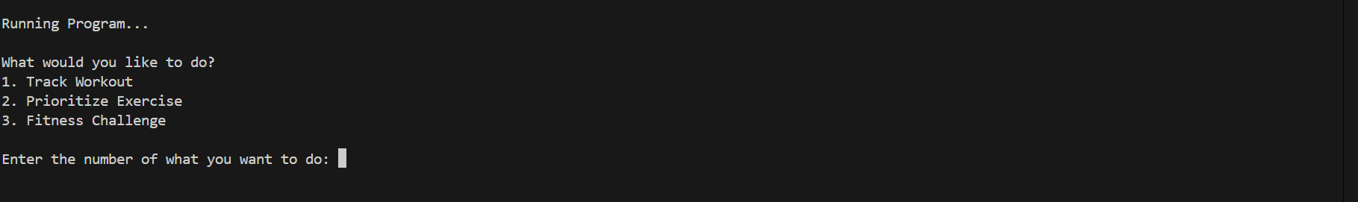

Then the Users can press the desired Exercise, after which they can either Set or Check their goals for that exercise can Log Data or check their already achieved High Score or Set, Calculate, and Check their Diet Plan.

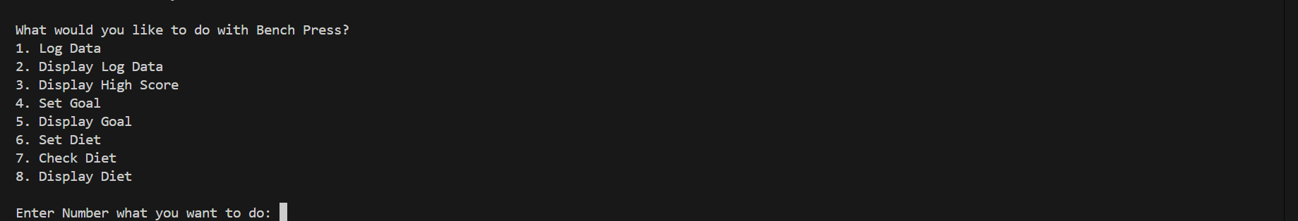

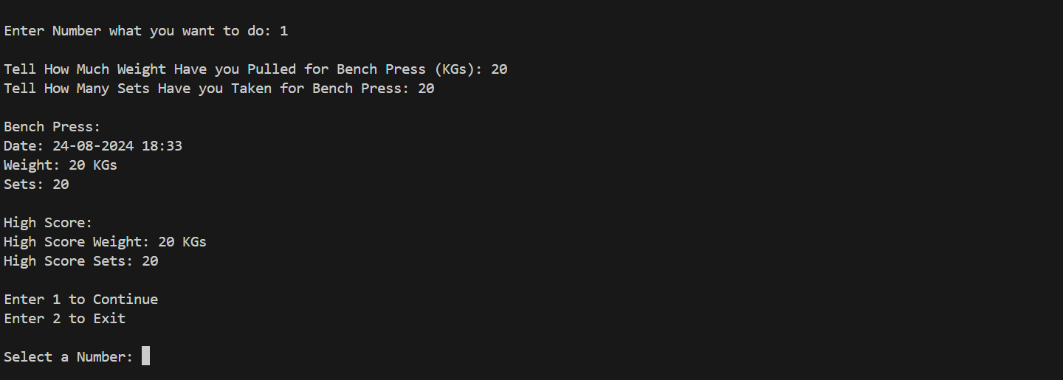

If the users Push the **Prioritize Exercises** option, they are met with the Exercises list and can select which exercise they want to prioritize, whenever a user starts the application, he/she meets their last achieved log data, and their set goal. The application will remind them if the User didn’t have Log Data for one day.

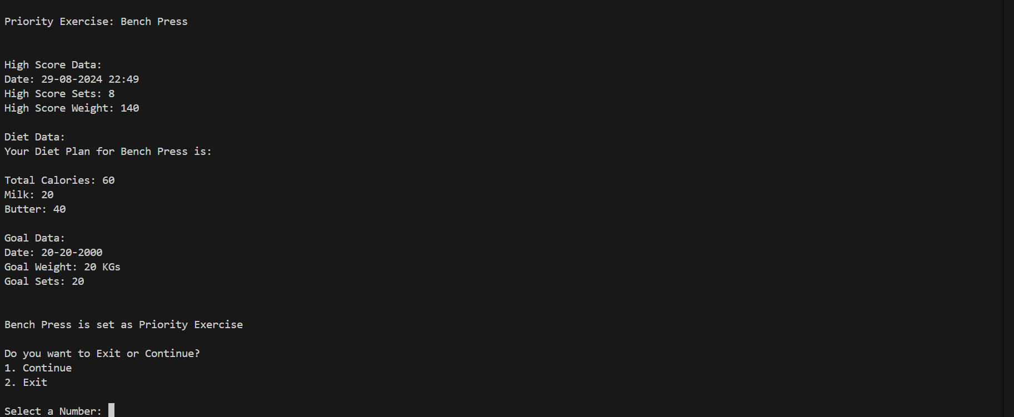

If the User presses the **Fitness Challenge** option, it gives them the option to Generate a Challenge, Display the Challenge, and Push their Limit. When the User presses the Generate Exercise Option the application gives them a challenge of a particular exercise.

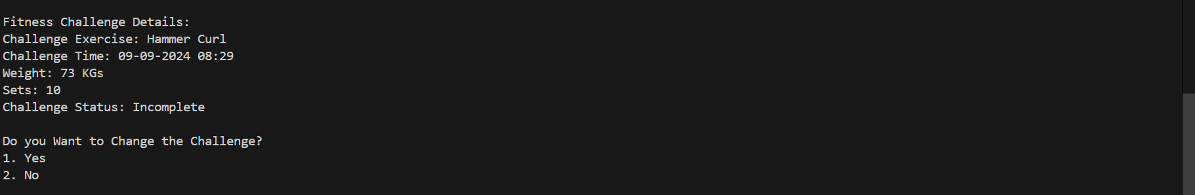

If the User presses Display the Challenge option it gives the User already set Challenge and the Challenge Status whether it has been completed or not. Users can complete this Challenge by commanding whether they have completed the challenge or not, when they come to Generate a new Challenge, the Application will automatically check the Log Data whether the User has completed the Exercise or not.

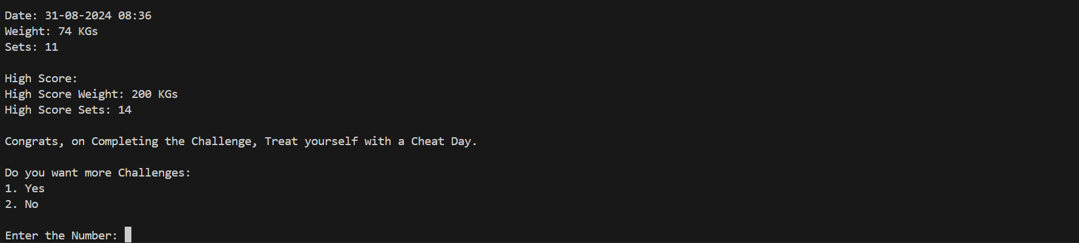

After completing each task, the application prompts whether they want to continue using it or exit.

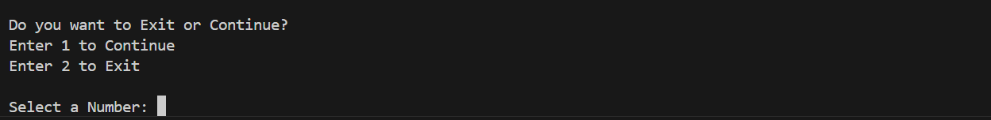

**Logic:**

The Application Logic works by preset functions, when a user presses the task, they want to do, that function runs up and runs by user instructions of predefined instructions. If the User presses the wrong option the application gives them an error of what they have done wrong.

